Free Community Event Night
Friday, August 27, 2021
Games – 7:00PM
Outdoor Movie Night – 8:30PM
At Chestnut Grove UM Church
450 Chestnut Grove Road
Dillsburg, PA 17019

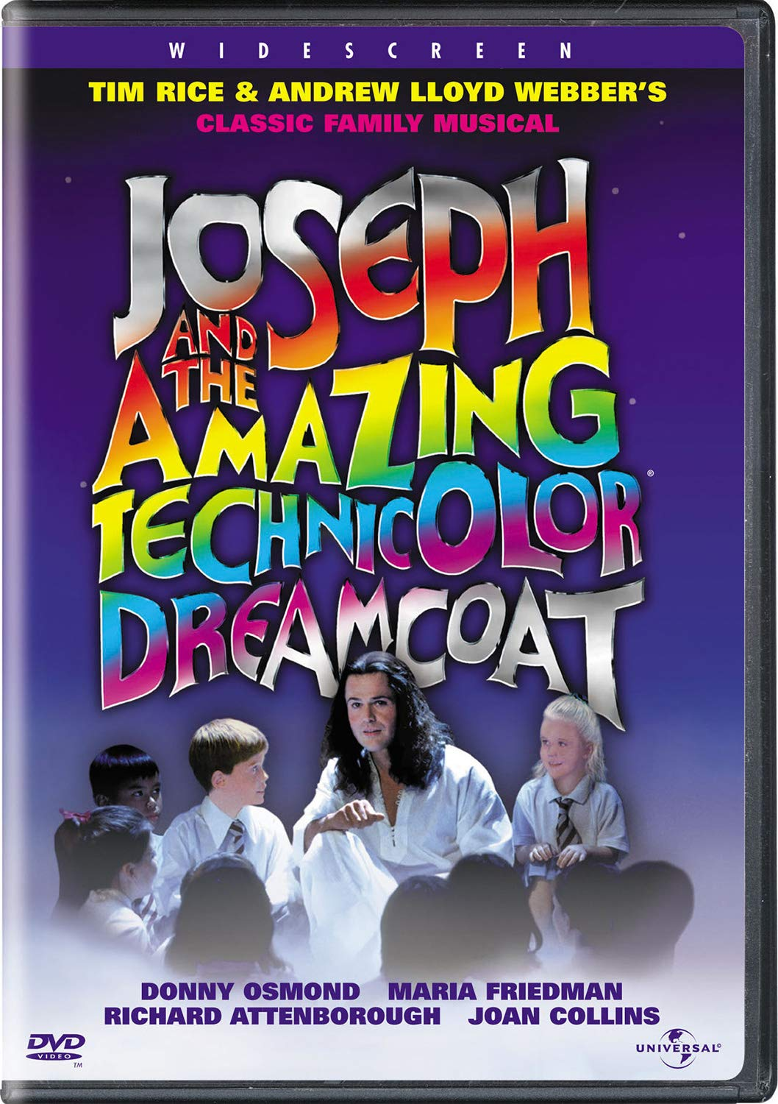
Snacks and drinks will be provided.
The movie event will be rain or shine; if there is severe weather, we will move inside to the sanctuary.

Questions: 717-432-8243

ALL ARE WELCOME! BRING A FRIEND AND HAVE FUN FILLED EVENING!

